

**Bandhutva (बन्धुत्व) : The perfect tool to foster meaningful professional connections on LinkedIn!**

**Overview:**

**Bandhutva** is a lightweight, browser-based extension designed for **LinkedIn users** to efficiently manage connection requests in bulk. It provides users with the ability to **selectively accept or reject multiple connection requests at once** on specific LinkedIn pages — enhancing productivity and ensuring intentional professional networking.

**Objectives:**

* Maintain visual consistency with LinkedIn's user interface.
* Streamline the process of managing LinkedIn connection requests.
* Provide the ability to accept or decline multiple requests simultaneously.
* Offer individual selection for granular control over networking.

**Project Requirements:**

**Technical Stack:**

* **Browser Extension:** Manifest V3 (Compatible with Chrome, Brave, and Edge)
* **Languages:** JSON, JavaScript, CSS
* **Targeted Web Pages:**

https://www.linkedin.com/mynetwork/invitation-manager/ https://www.linkedin.com/mynetwork/grow/

**Implemented Features:**

| **Feature** | **Description** |
| --- | --- |
| **Bulk Accept/Reject Buttons** | Adds buttons to accept or reject multiple requests at once |
| **Select All Checkbox** | Check/uncheck all requests with a single toggle |
| **Individual Selection Checkboxes** | Custom checkboxes beside each connection request card |
| **Bulk Actions Based on Selection** | Accept/Reject actions apply only to selected requests |
| **Minimal, LinkedIn-Aligned UI** | Styled buttons and control bar blending with LinkedIn's design |
| **Fade-in Animation** | Smooth UI animations for control bar appearance |
| **Icon Setup for Extension** | Custom icons for 16px, 48px, and 128px sizes |
| **Permission Scoped to Specific Pages** | Works only on the two LinkedIn pages mentioned above |

**Bandhutva Extension Usage Guide:**

To use the Bandhutva extension, follow these steps:

**1. Obtain the Extension Project:**

* Download the project folder. This folder should include:
  + `manifest.json`
  + `content.js`
  + An `icons/` folder containing favicon files.

**2. Install the Extension:**

* Navigate to the extensions page in your browser (Chrome, Brave, or Edge).
* Activate "Developer Mode."
* Select "Load Unpacked" and choose your project folder.

**3. Access LinkedIn:**

* Open the following LinkedIn pages:
  + <https://www.linkedin.com/mynetwork/invitation-manager/>
  + <https://www.linkedin.com/mynetwork/grow/>

**4. Utilize Bandhutva's Functionality:**

* A floating control bar will appear above the connection requests.
* Use the "Select All" checkbox to select or deselect all requests.
* Alternatively, select individual requests manually.
* Click "Accept Selected" or "Reject Selected" to perform bulk actions on the chosen requests.

Reference images:  
  
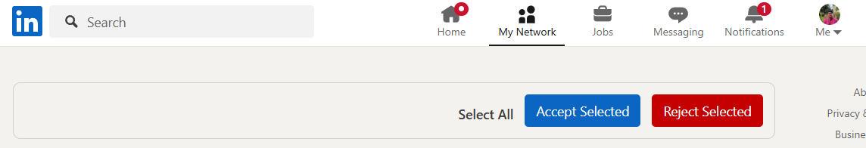

* https://www.linkedin.com/mynetwork/invitation-manager/

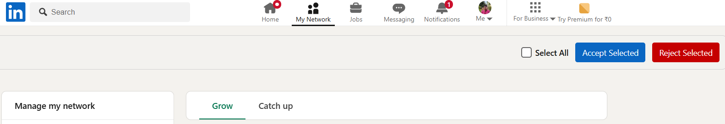

* https://www.linkedin.com/mynetwork/grow/